**File Handling:**

**1.Create a file**

**import** java.io.File;

**import** java.io.IOException;

**public** **class** CreateaFile {

**public** **static** **void** main(String[] args) {

// **TODO** Auto-generated method stub

**try** {

//Set the path of file to be created

// In this case Code.txt file will be created in path C:/Javaseleniumworld

File file = **new** File("E:/Javaseleniumworld/Code.txt");

// if file doesnt exists, then create it

**if** (!file.exists()) {

file.createNewFile();

}

} **catch** (IOException e) {

e.printStackTrace();

}

}

}

**Screenshot:**

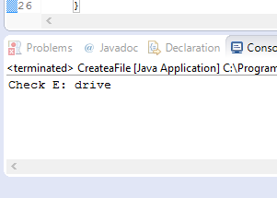

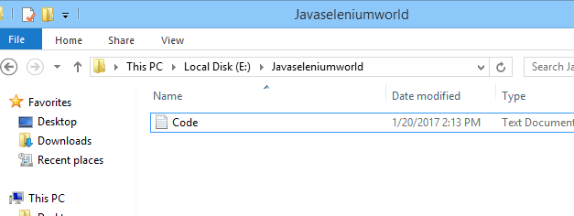

**2.Write to a file:**

**import** java.io.BufferedWriter;

**import** java.io.File;

**import** java.io.FileWriter;

**import** java.io.IOException;

**public** **class** WritetoFile {

**public** **static** **void** main(String[] args) {

// **TODO** Auto-generated method stub

**try** {

//String to written in the file - C:/Javaseleniumworld/Code.txt

String content = "Hello JavaSeleniumWorld.com";

File file = **new** File("E:/Javaseleniumworld/Code.txt");

// if file doesnt exists, then create it

**if** (!file.exists()) {

file.createNewFile();

}

//Use BufferedWriter to write to the file

FileWriter fw = **new** FileWriter(file.getAbsoluteFile());

BufferedWriter bw = **new** BufferedWriter(fw);

bw.write(content);

bw.close();

} **catch** (IOException e) {

//Display error message if an exception is encounterd while writing the file

e.printStackTrace();

}

}

}

**Screenshots:**

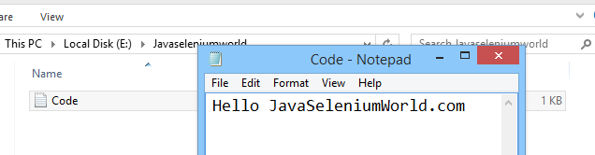

**3.Read from a file:**

**import java.io.BufferedReader;**

**import java.io.FileNotFoundException;**

**import java.io.FileReader;**

**import java.io.IOException;**

**public class ReadFromFile {**

**public static void main(String[] args) {**

**//Set the BufferredReader object to null intitally**

**BufferedReader br = null;**

**String strLine = "";**

**try {**

**//Point the br object to the file you want to read**

**//File to be read line by line - C:/Javaseleniumworld/Code.txt**

**br = new BufferedReader( new FileReader("E:/Javaseleniumworld/Code.txt"));**

**//Read the file Line by Line till Null value is encountered**

**while( (strLine = br.readLine()) != null){**

**//display each line**

**System.out.println(strLine);**

**}**

**} catch (FileNotFoundException e) {**

**//Display error message if File was not found**

**System.err.println("Unable to find the file");**

**} catch (IOException e) {**

**//Display error message if an exception is encounterd while reading the file**

**System.err.println("Unable to read the file");**

**}**

**// TODO Auto-generated method stub**

**}**

**}**

**Screenshot:**

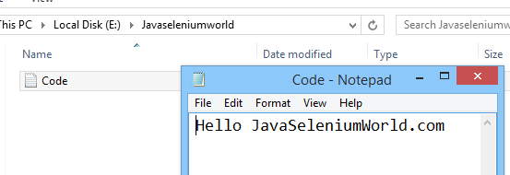

**4.Delete a file:**

**import** java.io.File;

**public** **class** DeleteFileExample {

**public** **static** **void** main(String[] args) {

// **TODO** Auto-generated method stub

**try**{

//File to be deleted - C:/Javaseleniumworld/Code.txt

File file = **new** File("E:/Javaseleniumworld/Code.txt");

**if**(file.delete()){

System.***out***.println(file.getName() + " is deleted!");

}**else**{

System.***out***.println("Delete operation is failed.");

}

}**catch**(Exception e){

e.printStackTrace();

}

}

}

**Screenshot:**

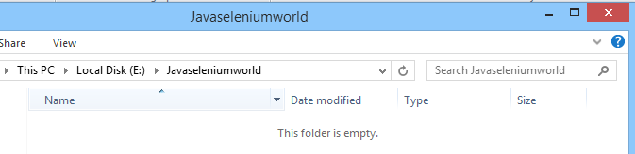

**5.List files in a folder:**

**import** java.io.File;

**public** **class** ListfilesinFolder {

**public** **static** **void** main(String[] args) {

// **TODO** Auto-generated method stub

//Set the path of folder for which you wish to list name of all the files stored

File file = **new** File("E:interview");

// Object files contains all the files under the selected folder

File[] files = file.listFiles();

//for each file in the folder

**for**(File f: files){

System.***out***.println(f.getName());

}

}

}

**Screenshot:**

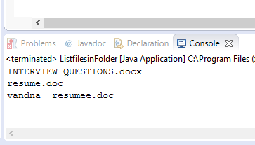

**6.List files with specific extension:**

**import** java.io.File;

**public** **class** Listfileswithspecificextension {

**public** **static** **void** main(String[] args) {

// **TODO** Auto-generated method stub

//Set folder path for which you wish to get name of the files stored with specific Extension

File file = **new** File("E:/interview");

// Object files contains all the files under the selected folder

File[] files = file.listFiles();

//for each file in the folder

**for**(File f: files){

//capture all filenames with .zip extension

//You can mention .txt for extracting files wth .txt extension

**if**(f.getName().toLowerCase().endsWith(".doc")){

//Print the filename with .zip extension

System.***out***.println(f.getName());

}

}

}

}

**Screenshot:**

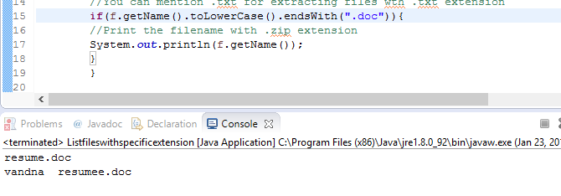

**7.Create a folder:**

**import** java.io.File;

**public** **class** Createafolder {

**public** **static** **void** main(String[] args) {

// **TODO** Auto-generated method stub

//Set the path of Folder to be created

// In this case Folder Javaseleniumworld will be created in path C:

File file = **new** File("E:/Javaseleniumworld");

File file1 = **new** File("E:/Javaseleniumworlddd");

//If the folder doesnot exist then create it

**if** (!file.exists()) {

**if** (file.mkdir()) {

System.***out***.println("Directory is created!");

}

**else** {

System.***out***.println("Failed to create directory!");

}

}

**if** (!file1.exists()) {

**if** (file1.mkdir()) {

System.***out***.println("Directory isss created!");

}

**else** {

System.***out***.println("Failed tooo create directory!");

}

}

}

}

**Screenshot:**

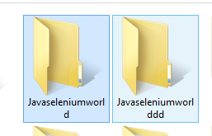

**8. Move file from one folder to another:**

**import** java.io.File;

**public** **class** MoveFiletoanotherDirectory {

**public** **static** **void** main(String[] args) {

// **TODO** Auto-generated method stub

//Move the file from - C:/Javaseleniumworld/Code.txt to - C:/QTPworld/Code.txt

File from = **new** File("E:/Javaseleniumworld1/Code.txt");

File to = **new** File("E:/Javaseleniumworlddd2");

//Rename

**if** (from.renameTo(to))

System.***out***.println("Successfully Moved the file");

**else**

System.***out***.println("Error while moving the file");

}

}

**9. Delete a folder:**

**import** java.io.File;

**public** **class** DeleteaFolder {

**public** **static** **void** main(String[] args) {

// **TODO** Auto-generated method stub

//Set the folder for which delete folder ,all the sub folder and it contents

File filez = **new** File("E:/Javaseleniumworld");

*deleteFolder*(filez);

}

//Function to recursively delete all the sub folder and its contents

**public** **static** **void** deleteFolder(File folder) {

File[] files = folder.listFiles();

**if**(files!=**null**) { //some JVMs return null for empty dirs

**for**(File f: files) {

**if**(f.isDirectory()) {

*deleteFolder*(f);

System.***out***.println("deleted:");

}

**else** {

f.delete();

}

}

}

folder.delete();

}

}